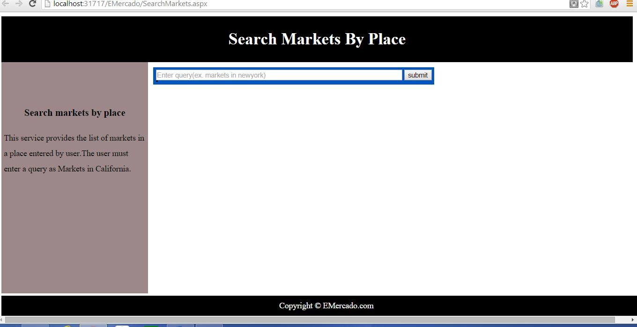

Search Markets by Place Page

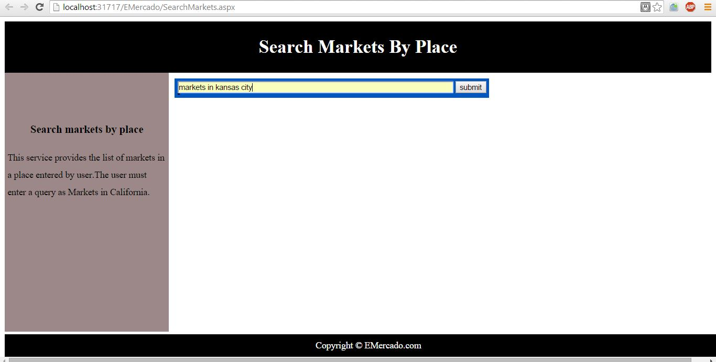

Search Markets by Place –Entering Query

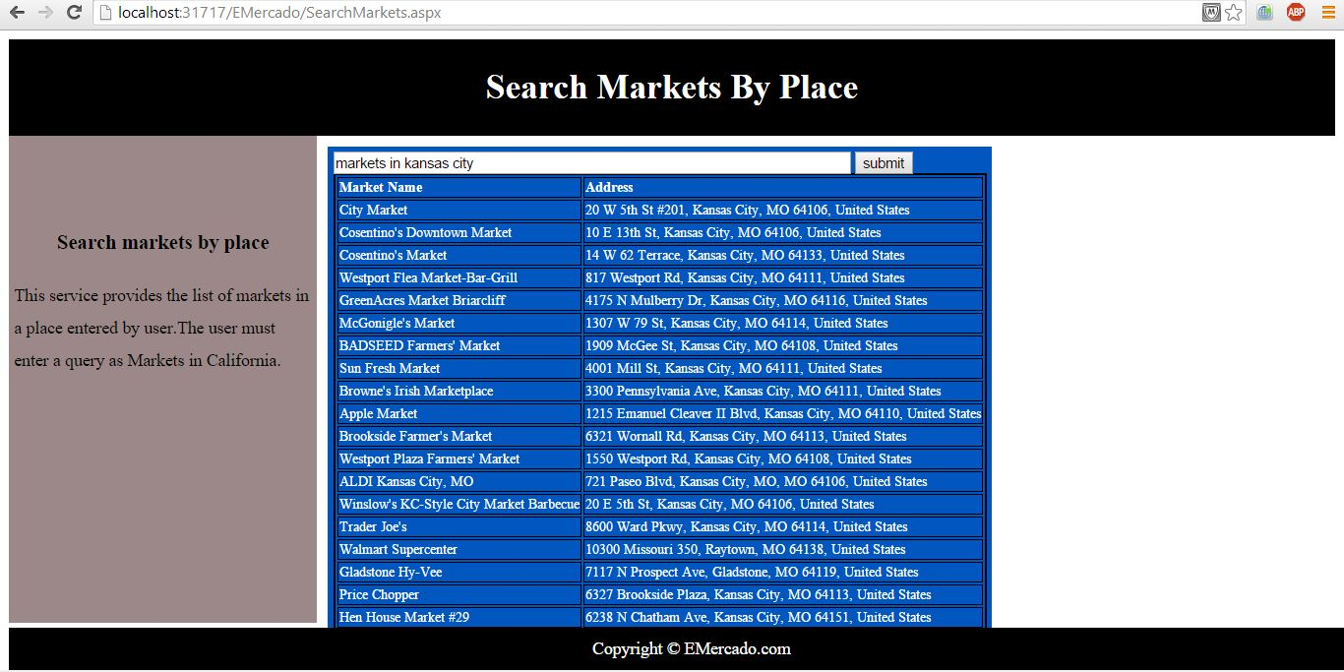

Search Markets by Place –Displaying markets

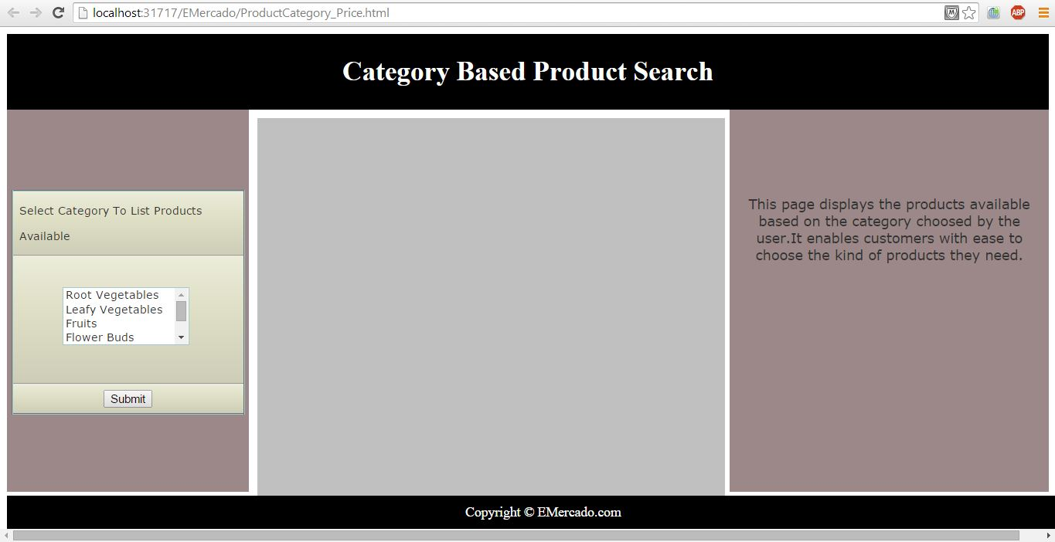

Category Based Product Search page

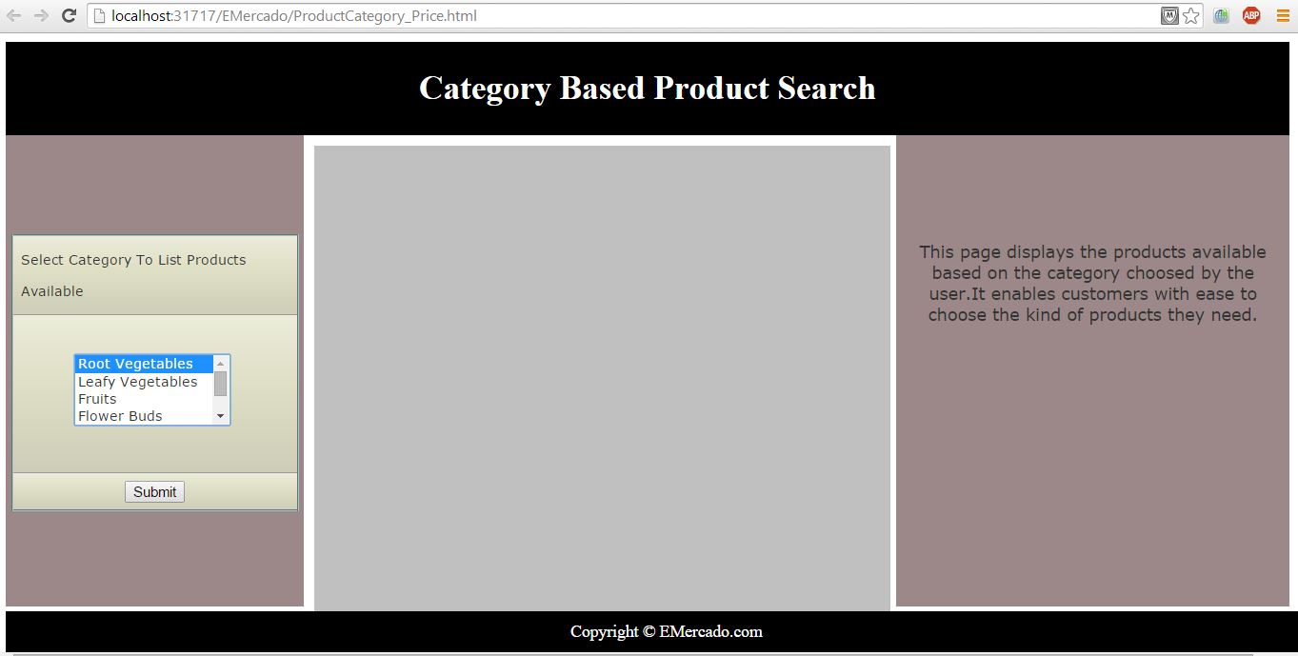

Category Based Product Search page- Selecting a category

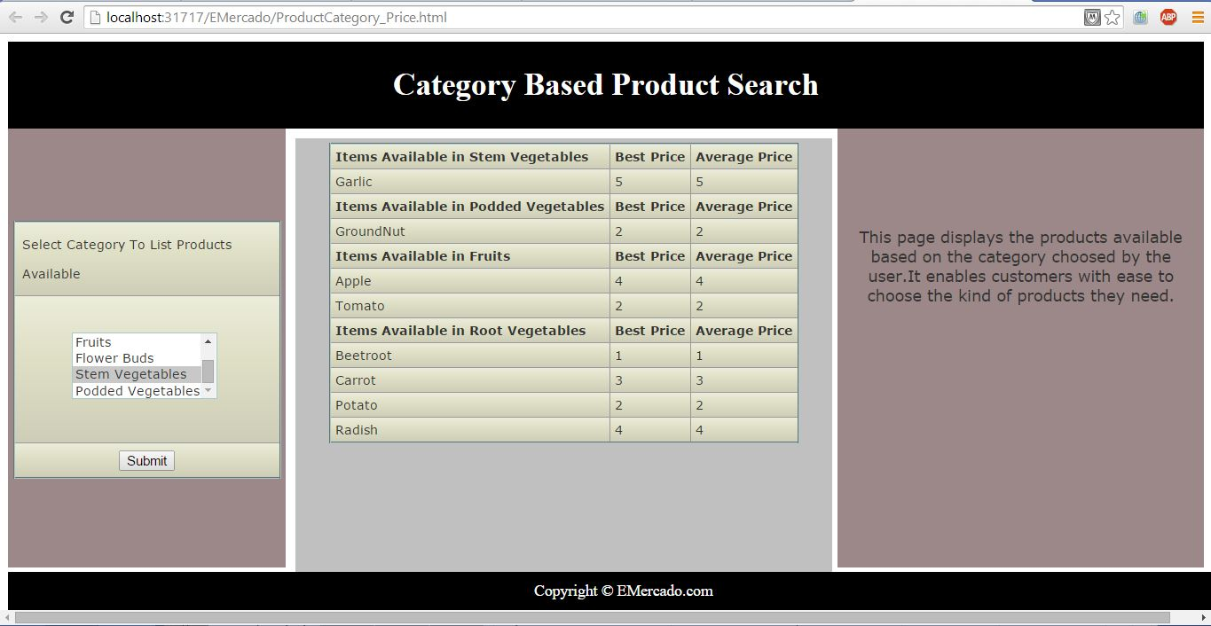

Category Based Product Search page-output

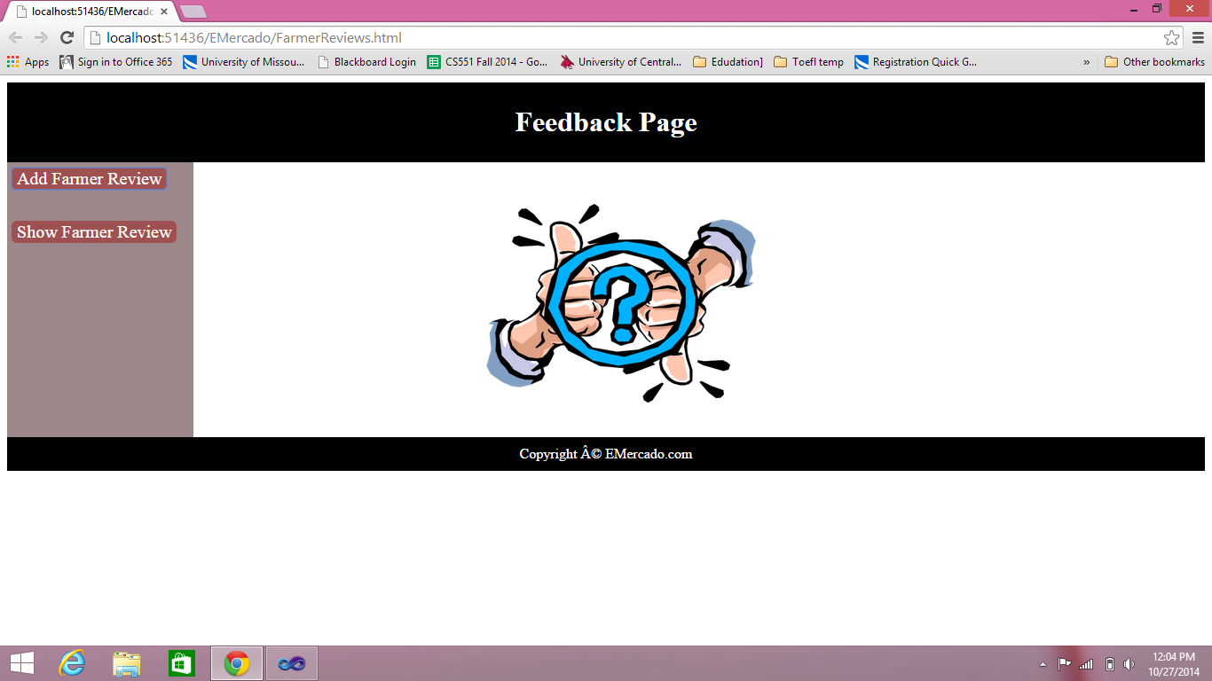

Feedbackpage

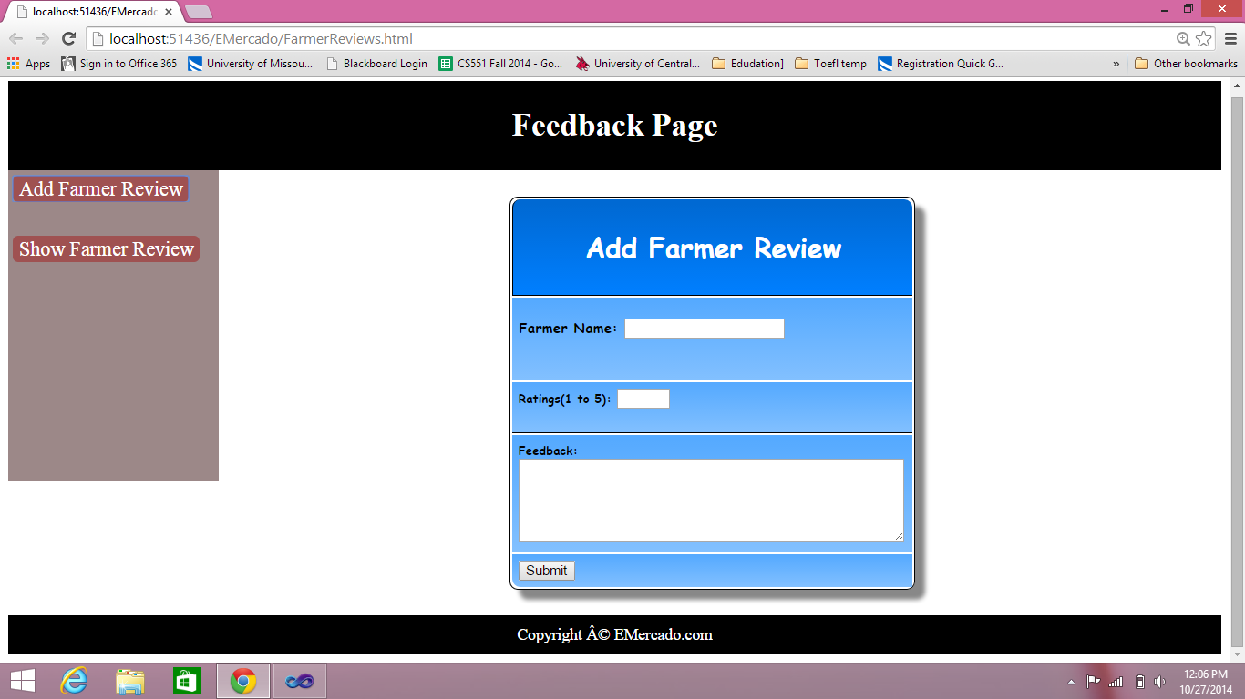

Add Farmer review page

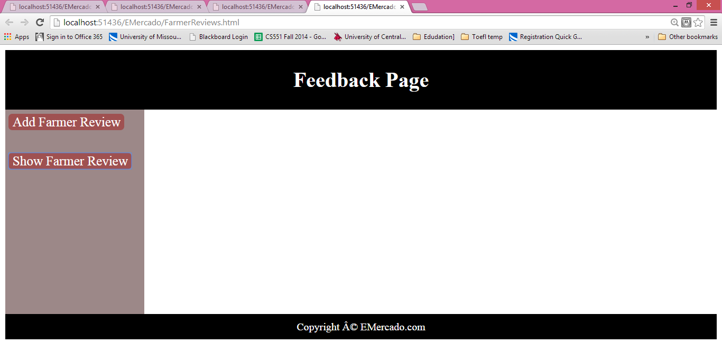

View Review page.

Project members’ name/ID

Barath Viswanatham/47

Vijaya Bhasker Reddy Singireddy/53

Vamsi Krishnam raju Tirumalaraju/38

Vijay Akinnepally/1

* **Import Existing Services/API**

1. Google Places: This service is used to handle the user queries about the places.
2. Text to speech: This service is used to convert text to speech.
3. Farmer Market API: This is used to get the near-by markets information.

* **Detail Design of Services**
  + WSDL: Service description
  + Class diagram
* 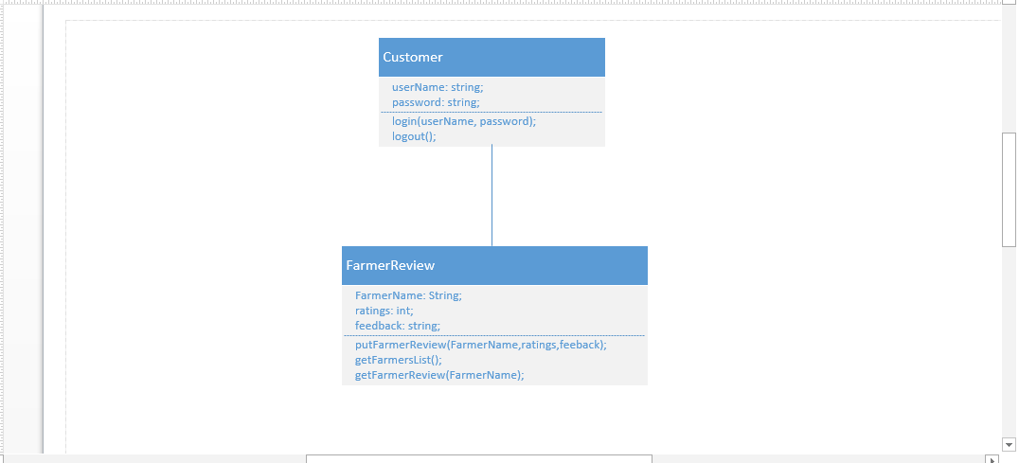Web Services: 1)best price class diagram
* 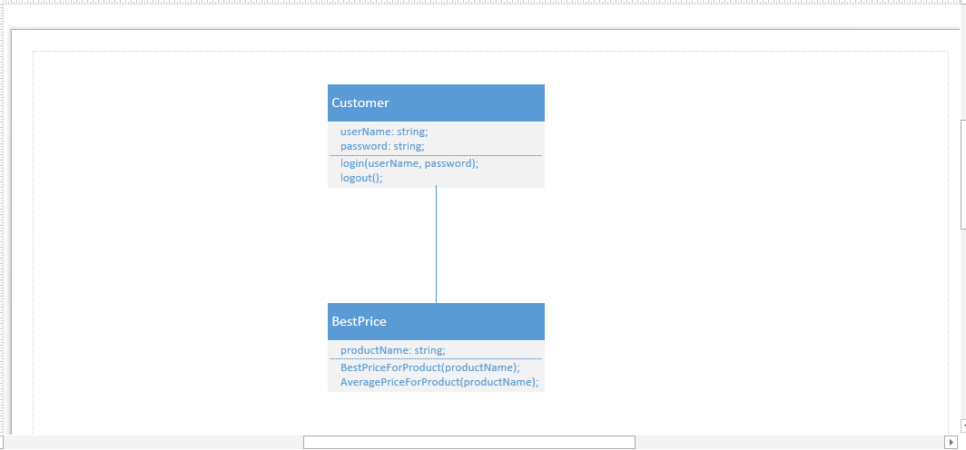
* 2)Farmer review class diagram:
* 
* 3)search by category class diagram
* 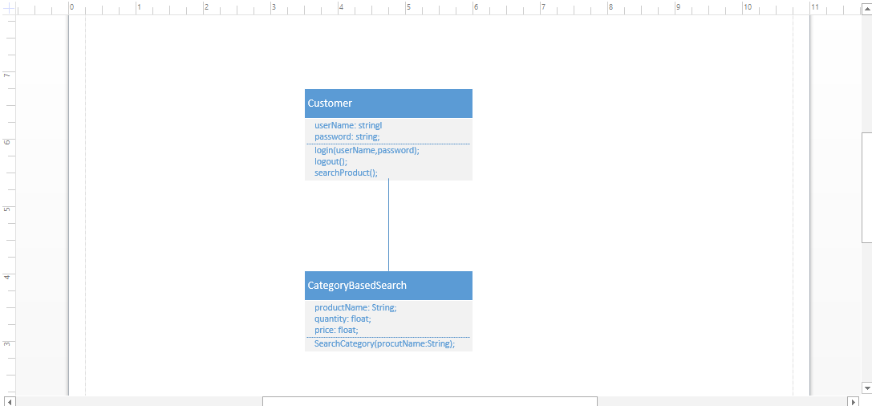
  + Design of Mobile Client Interface:

HTML, CSS, JAVASCRIPT, TWITTER-BOOTSTRAP.

* **Implementation**
  + Implementation of services:

1. **Best Price and Average Price for Product:** This is a rest service. This service takes product name as input. It calculates the minimum price for the product from all farmers who are selling that product. This will be very useful information for user to get Best Price for product he/she is going to purchase.

The 2nd service in this is getting average price for the product. This will give information to customer how much benefit he/she is gaining from the Best Price.

In this error cases are also handed, if no product is available it returns “” (null).

**Service URL:** http://kc-sce-cs551-2.kc.umkc.edu/aspnet_client/Group12/Project/BestPrice/BestPrice/Service1.svc/GetBestPrice

1. **Category based Products Retrieval:** This is a rest service. This service takes category name as input. This service returns all the products available in the category by looking from database.

If no available items in the category it returns null.

**Service URL:** <http://kc-sce-cs551-2.kc.umkc.edu/aspnet_client/Group12/Project/CategorySearch/CategorySearch/Service1.svc/SearchProductsByCategory/>

1. **Put and Get Farmer Reviews:** This is a rest service. This service inserts the farmer reviews in to database. It takes input customer Name, FarmerName, Rating and Reviews. The data is store in the table farmerReview table.

The 2nd service in this is to get all the farmer reviews for a given farmer (farmer name is provided as input to service). If no reviews available for farmer ir returns NULL.

Service URL: <http://kc-sce-cs551-2.kc.umkc.edu/aspnet_client/Group12/Project/FarmerReview/FarmerReview/Service1.svc/PutFarmerReview/>

<http://kc-sce-cs551-2.kc.umkc.edu/aspnet_client/Group12/Project/FarmerReview/FarmerReview/Service1.svc/GetFarmerReview>

<http://kc-sce-cs551-2.kc.umkc.edu/aspnet_client/Group12/Project/FarmerReview/FarmerReview/Service1.svc/GetFarmers>

**4 Get Farmers Available:** This is a rest service. This service returns all the available farmers present in the database. This service is useful in showing all farmers, so that in UI farmer can be selected to get particular farmer review.

1. **Registration Service:** This a Restful service used for registration of customer and farmer, that holds all the registration details.
2. **Search for markets using queries:** This service is used to display markets based on the queries entered by customer.

**Best Price and Average Price for Product:**

**Service URL:** http://kc-sce-cs551-2.kc.umkc.edu/aspnet_client/Group12/Project/BestPrice/BestPrice/Service1.svc/GetBestPrice

**Category based Products Retrieval:**

**Service URL:** <http://kc-sce-cs551-2.kc.umkc.edu/aspnet_client/Group12/Project/CategorySearch/CategorySearch/Service1.svc/SearchProductsByCategory/>

**Put and Get Farmer Reviews:**

Service URL: <http://kc-sce-cs551-2.kc.umkc.edu/aspnet_client/Group12/Project/FarmerReview/FarmerReview/Service1.svc/PutFarmerReview/>

<http://kc-sce-cs551-2.kc.umkc.edu/aspnet_client/Group12/Project/FarmerReview/FarmerReview/Service1.svc/GetFarmerReview>

<http://kc-sce-cs551-2.kc.umkc.edu/aspnet_client/Group12/Project/FarmerReview/FarmerReview/Service1.svc/GetFarmers>

**Scrumdo link:**

<https://www.scrumdo.com/projects/project/e-mercado/iteration/111973>

**Github Url:**

Implementation status report

Work completed:

Description- Implementation of Services -Best Price and Average Price for Product,Category based Products Retrieval,Get Farmers Available,

Responsibility (Task, Person)-Bharath viswanadham

Time taken (#hours) 1 week

Work completed:

Description-Search for markets using queries and its design page.

Responsibility (Task, Person) Vijaya bhasker reddy Singireddy

Time taken (#hours) 1 week

Work completed:

Description-Get & Put farmer reviews and its design page

Responsibility (Task, Person)-Vamsi Krishnam raju Tirumala raju

Time taken (#hours)-1 week

Work completed:

Description-Registration service

Responsibility (Task, Person)- Vijay Akkinepally

Time taken (#hours)-1 week.